Test plan

Software requirement

The following software is required for running the PFM application:
- JDK 1.6
- Tomcat 6.0 or above
- Apache-activemq 5.5.0
- PFM.war

Deploy the application

The following steps will guide you through the deployment process
- Start Apache-activemq
- Copy the PFM.war into $TOMCAT_HOME/webapps
- Start tomcat
After tomcat finishes the start up process, PFM.war will be extract into a folder named PFM located in $TOMCAT_HOME/webapps

Prepare test data

Test data is stored in text files located in $TOMCAT_HOME/webapps/txt folder.
Each file contains a test case. Each line in the file is a piece of message, which is received by the PFM system. A test case consists of multiple messages.
A message is in the format of name/value pairs like “event:TriageScore,timestamp:2011-11-11/03-30-00, Provider_ID:Nurse745774,CTAS:2,Patient_ID:Pa123456”
New test cases need creating with such kind of format.

Run test cases

Tests can be run through Web UI. Assume the tomcat is running on port 8080, this URL: http://localhost:8080/PFM/msgList.gsp can show you the testing page:
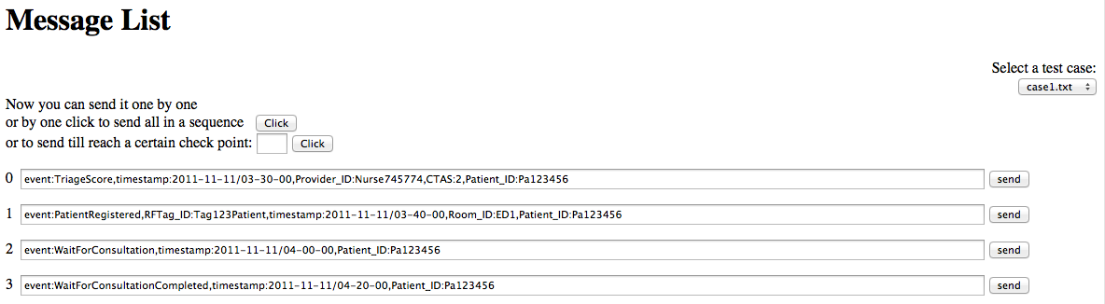
Diagram1: Testing Web UI
On the top right hand side there is a test case selection box, all the test case file names will be listed as options. The messages from the selected test case will be loaded into the page with indexes.
A test case can be done in different way:
- Messages can be sent one by one manually by clicking the send button located after the message.
- All messages can be sent in sequence with one click.
- Give a checkpoint number k (index of the last message) and click the button, the messages from index 0 to index k will be sent in squence.

See the execution result

Open this URL: http://localhost:8080/PFM/patient/getPatientMap you can see a map with room Id and some blue dots on it. Each blue dot represents the patient who is in the room. You can check if the patient is in the room as defined in the test case.
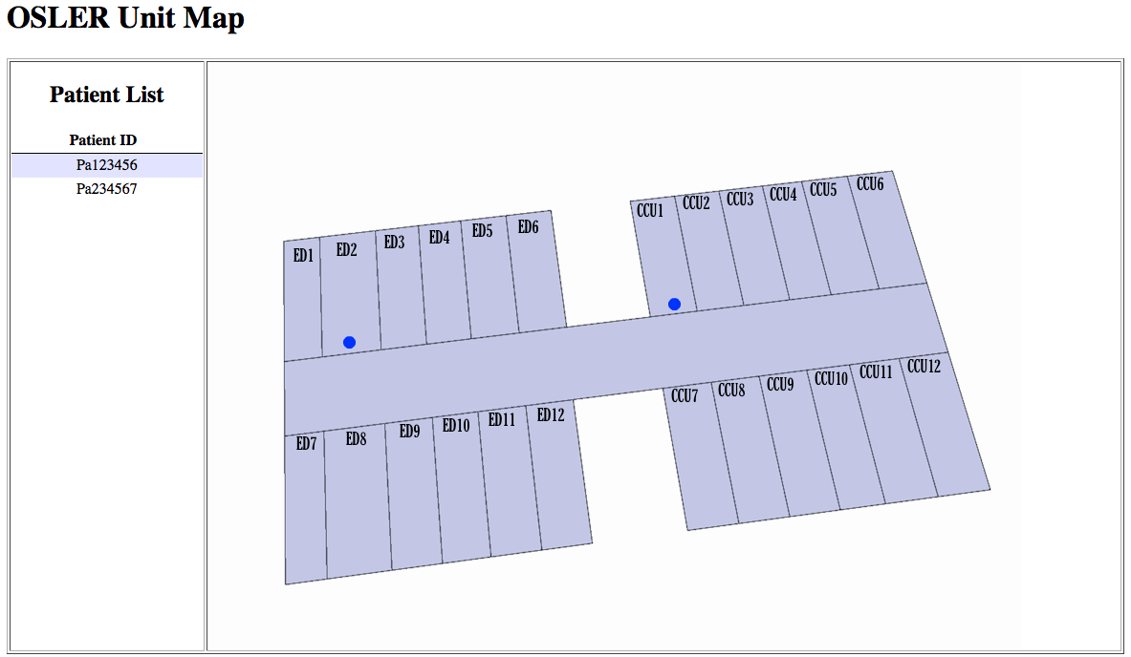
By clicking the patient id on the patient list or the blue dot, you can see a page that shows the patient details.

Test the current wait time
Modify the timestamp in the message to the format of “*/hh-mm-ss”, it will represent today’s date. So the current patient wait time can be calculated based on the test case execution time.
Current patients wait time table can be seen with this URL: http://localhost:8080/PFM/patient/getCurrentPatientsWaitTime
